**DAILY ONLINE ACTIVITIES SUMMARY**

|  |  |  |  |  |  |  |  |  |
| --- | --- | --- | --- | --- | --- | --- | --- | --- |
| **Date:** | **24/06/2020** | | | | | **Name:** | **Hanan Saleem Baji** | |
| **Sem & Sec** | **4th SEM 'A' Section** | | | | | **USN:** | **4AL18CS024** | |
| **Online Test Summary** | | | | | | | | |
| **Subject** | | N/A | | | | | | |
| **Max. Marks** | | N/A | | **Score** | | | N/A | |
| **Certification Course Summary** | | | | | | | | |
| **Course** | **1.Predictive Modeling and Analytics** | | | | | | | |
| **Certificate Provider** | | | **1. Great Learning Academy** | | **Duration** | | | **1. 3 hour** |
| **Coding Challenges** | | | | | | | | |
| **Problem Statement:** 1. Given the marks of all students, calculate the median.  2. Write a C Program to Sort a stack using a temporary stack.  .  For example | | | | | | | | |
| **Status: completed** | | | | | | | | |
| **Uploaded the report in Github** | | | | | **Yes** | | | |
| **If yes Repository name** | | | | | 1. <https://github.com/saleemhananbaji/Python-Coding> 2. <https://github.com/saleemhananbaji/C-coding> | | | |
| **Uploaded the report in slack** | | | | | **Yes** | | | |

Certification Course Details: As the continuation of online course, I have completed concepts of multicollinearity and concepts of R-square.

Snapshot:

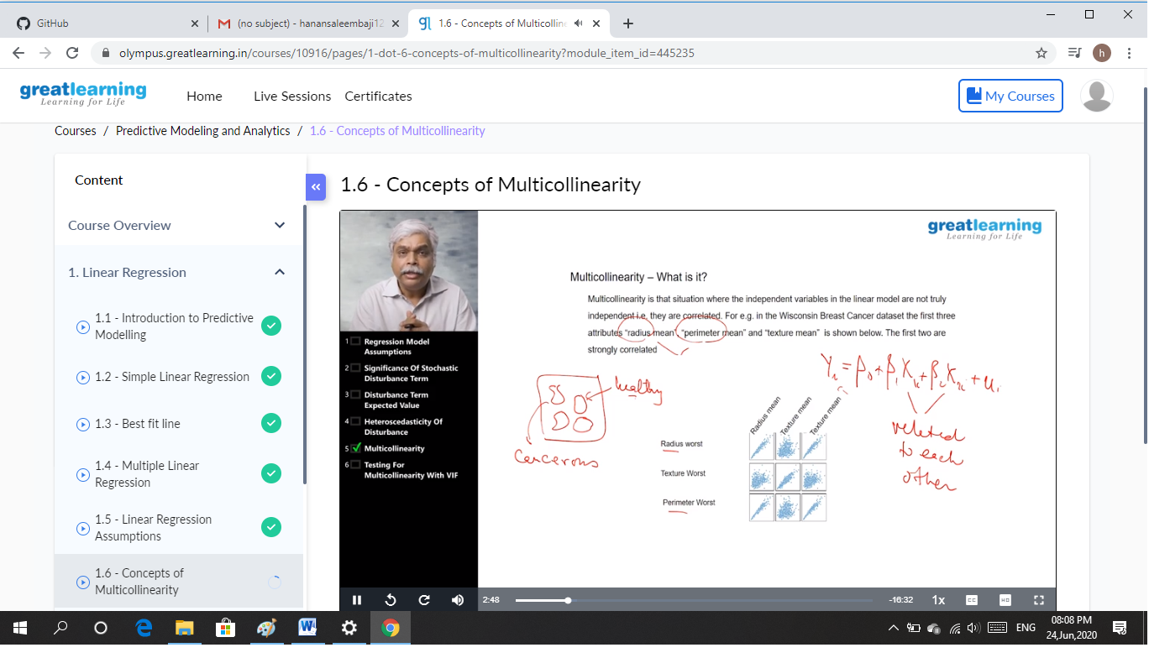

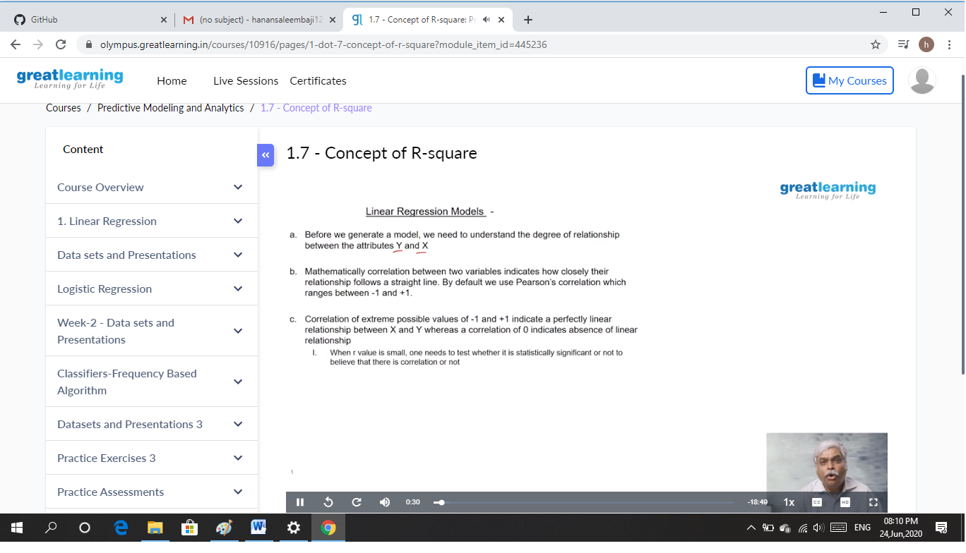

CODING CHALLENGES DETAILS: Problem statements

1. Given the marks of all students, calculate the median.

Input:

The first line of input takes the number of test cases, T. For each test case there will be two lines. The first line contains an integer N denoting the number of students, and second line contains N space seperated integers which denotes the marks of N students.

Solution: Uploaded it in github

Snapshot:

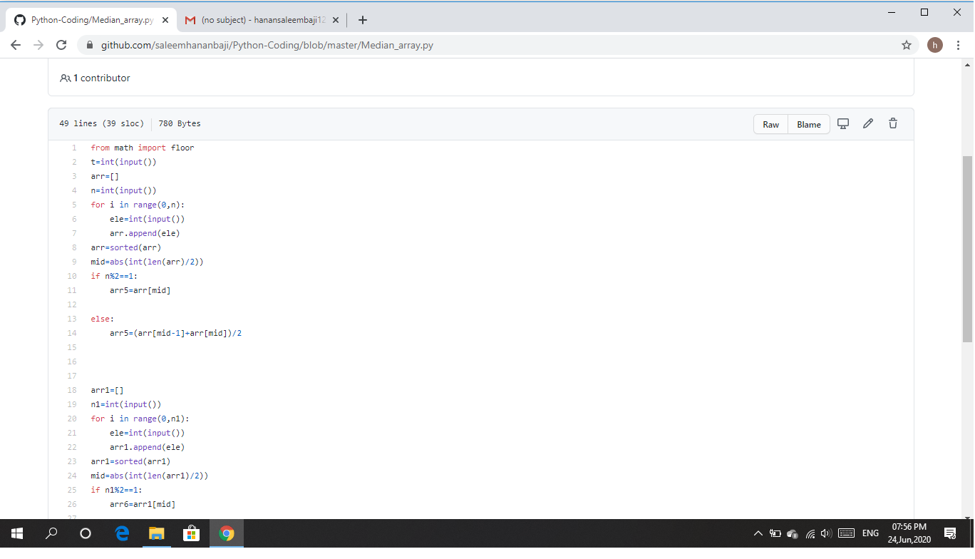

1. Write a C Program to Sort a stack using a temporary stack.

Solution: Uploaded it in github

Snapshot:

